Queen of Peace - Our Story
- Mission

- There was a mission in Western Canada, and the Order of Preachers was not present.
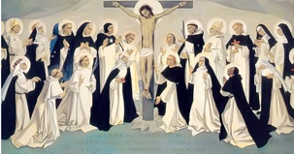
- Vancouver is a rapidly growing Archdiocese and a door to Asia.
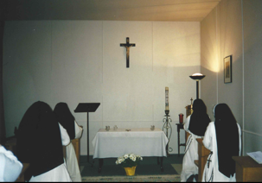
- On the eve of the year 2000, the Master of the Order of Preachers, Brother Timothy Radcliffe, called all the branches of the Order to respond to this mission together. The friendship and mutual support between friars, sisters, nuns and lay is efficacious for the mission. This was the way the Dominican Order began.
- How could the contemplative nuns respond to this call ? No single monastery could begin a foundation or provide the nuns.
- Brother Timothy encouraged creativity and innovation for the sake of the mission. He asked the autonomous monasteries to collaborate and called for volunteers from various monasteries.
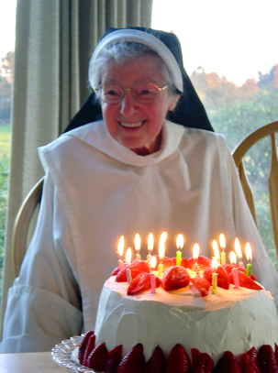
- Five nuns volunteered. They arrived in Vancouver with a van, $700 between them, and an intrepid determination to establish a Dominican monastery.
- They were not young. In fact, Sister Maria Dominica was about to turn 80 and had never left her beloved monastery. She was compelled by the mission and responded to the call of the Master. She became a pillar of the foundation.
- These five nuns had been formed in different monasteries with different cultures, and had strong conceptions of what perfect Dominican monastic life should be.
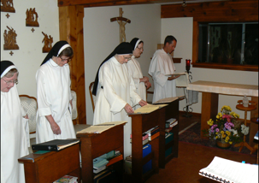
- There were those who were dedicated to perpetual adoration, others to perpetual rosary and each were attached to a particular liturgy.
- With this reality confrontation, began the period of dispossession, a dying to individual ‘dreams’ … a time of forming a common vision.
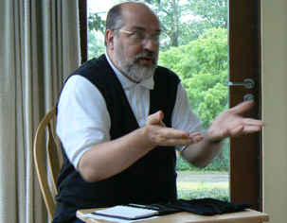
- It was a difficult passage. What were only ‘leeks and onions of Egypt’ and what were the essentials? Trying to reproduce what they lived in the past was not working because the Lord was doing something new.
- Indeed, the Master of the Order quoted Isaiah : Do not remember the former things, or consider the things of old. I am about to do a new thing: now it springs forth, do you not perceive it? I will make a way in the wilderness. Little did he know what a prophetic word that was!
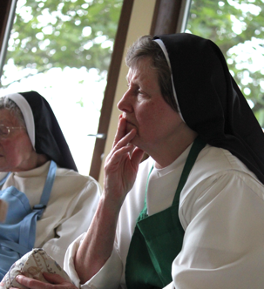
II. Listening

- We walked together and we listened to one another in our deepest aspirations as well as the gifts that each sister brought to the foundation.
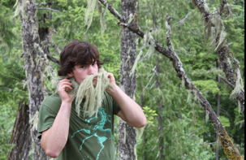
- We did common study in order to listen together to ancient sources of monasticism, sources further back than our 17th century monasteries. We asked the question: How could these fundamental intuitions be transposed into this Western Canadian context, in our time.
- We listened to the people who came to our door. They echoed those who, in the time of Jesus, said to Philippe, “we want to see Jesus” People are searching.
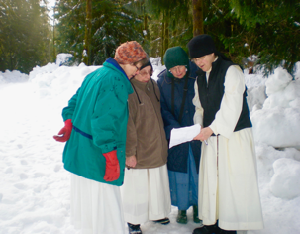
- Listening to Canadians, we perceived that the quest for adventure and for beauty in nature is a quest for God.
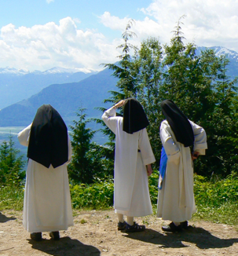
- We also listened to circumstances; the place where we had initially settled was wonderfully comfortable and cozy. Only, the zoning restrictions prevented us from growing or providing monastic welcome. The temptation was to stay in our comfort zone and die. A beautiful piece of land was available but it was within 5 kilo-meters of three other monastic communities.
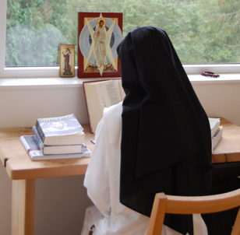
- Why light our little lamp where there was already plenty of light shining through those beautiful monastic communities? In 2009 we decided to search for property where there was no other presence of religious communities: in the Upper Squamish Valley. It is on the edge of wilderness, accessible to Vancouver and yet off the beaten path, in the ancestral territory of the (Squamish Nation).

III. A Preaching

- Dominican nuns are an integral part of the Order of Preachers …we are a preaching.
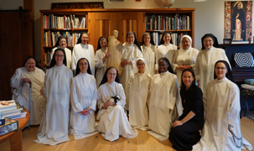
- Consecrated to God and centred upon His Word, our life is intentionally structured so that we may listen, ponder, study and celebrate the Word, so that this Word may dwell richly in our hearts.
- This Word becomes flesh in the context of community life, it is the community that radiates more than any individual, it is a preaching.
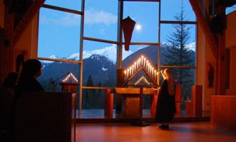
- The natural beauty of our location is a preaching.
- Folks who would not be caught dead in a church are drawn by the beauty of the environment, the chapel and the liturgy.
- There, God is able to welcome and speak directly to their hearts.
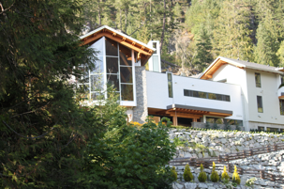
- Someone with a Celtic soul called our chapel a thin place; where the veil between the visible and invisible are so close.

IV. Building in Friendship
A Sacred Space
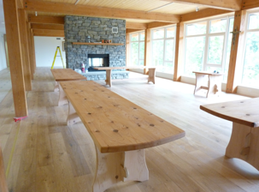
- When building, in 2011, we tried to honour the age old monastic architectural principles while using West Coast materials:
- Simple and spare / wood and stone
- The trees that came down for the building were milled by our friend Dan who is a neighbour.
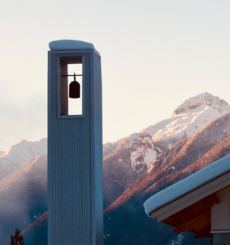
- He made our refectory tables, benches, desks and library shelving.
- The liturgical furniture was crafted by an indigenous man from local basalt (the alter still has lichen on it).
- The bell in our bell tower is made by another friend out of a propane tank cut in half.
- By hiring local architects, builders and contractors crafts persons not only was the monastery built but also a network of friends.
- Consultants, engineers, and folks committed to the care of creation usually end up coming for vespers. Basically, the chapel and community of Queen of Peace has become a spiritual oasis, a sacred space of beauty and peace.
- So many people are longing for a sacred space of beauty and peace where they are carried by the liturgy and can sink into that silence where the shimmering presence of God is revealed.

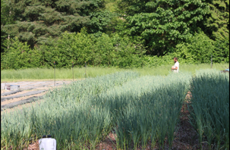
An Organic/Biodynamic Farm
- Upon our arrival, we were approached by a young man, Stefan, who was looking for land to do organic / biodynamic gardening.
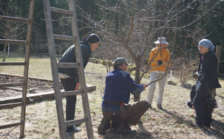
- Yes ! We would share the land. It was win /win. This would allow us qualify to have farm status.
- Stefan is inspiring by his love for the land his nutrient dense vegetables,
- and the way he is passing on his knowledge to the community of sisters.
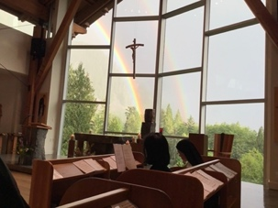
- He rejoices when he hears the bell knowing that we join him in praying for the earth. More than ever, we are simultaneously listening to the Word of God and to all of creation.
- We hear it’s groaning. We carry the beauty and the suffering of all creation in the intimate sanctuary of our hearts.

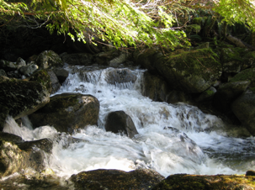
Generating clean electricity
- We recently completed the installation of a micro hydro electric plant. The monastery now generates its own power. We have traded in our vehicle for a used electric car.
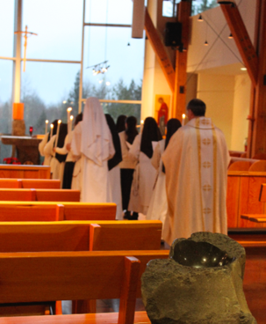
- The young women who have joined us are very sensitive to our relationship with creation.

V. A Life of Prayer
- These young women are looking for strong, visible, authentic religious life.
- Fundamentally, it is the life of prayer that is attracting young women to our community.
- They believe that prayer is a way of loving both God and humanity…
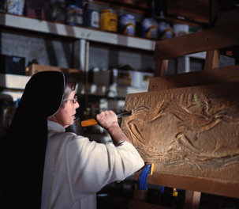
- that prayer is vital and extremely urgent at this time …for the sustaining and healing of our beloved world … they are staking their lives on it.
- By their lives totally consecrated to God and centred up on His Word. This Word is also expressed and spread through our work of artistic creation.
- Our monastic arts, soap, candles, sculpture, pottery and icons workshops are of great interest to them.

VI. Squamish ‘Mother of the Wind/ Spirit’
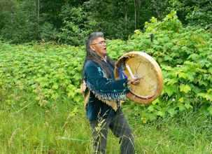
- As I mentioned, we live in the tradition territory of the Squamish Nation. We were very honoured when the spiritual elders of the Salish people,
- blessed both the land and community with their presence, prayer and teaching.
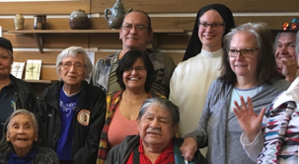
- Squamish is the people, Squamish is the land, Squamish is the cedar, Squamish is the salmon. They are all one. Like the the cedar and salmon Squamish people are generous. They had an economy of gift giving.
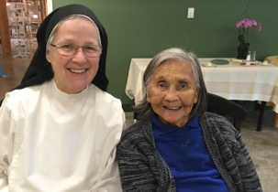
- We waited a long time before the elders accepted an invitation to come to the monastery. When they did so, we decided to share a meal with them. They were quiet at first but by the time we got to the pie and ice cream the laughter could be heard as far as the chapel. Near the end of the afternoon they began to share their stories. A novice describe our time together as Eucharistic, Jesus was truly mysteriously present.
- An Squamish elder encouraged us simply to listen to the land that has welcomed us.
VII. Listening together
- So I listened to the salmon asking what she may say to us.
- She just swam on.
- This intrepid salmon spared no effort on her long journey returning back to the source, to her origins, to the place where she would give her life giving life. She reminds us of our sources and of giving our lives.

- I asked the cedar, and it stood there with its roots sunk deep into her ground. Because it was so old, it was capturing masses of carbon and is a mother to a multitude of trees. The massive mycorrhisal fungal network connected to her roots she sustains and nourishes the whole forest. She reminds us to stay root in our sources of Life and thereby give life.

- Turning, I looked up at the glacier and gazed upon its ancient beauty.
- There she was, consenting to being still and exposed to the suns rays.
- By doing so, rivers of living water flow into our world, irrigating it and making it fruitful. She reminds us that we are not wasting away by our stability in prayer but a source of grace for the world.

- Who knows the fruitfulness of our life together, especially our elderly?
- We believe that we are one with you and that Queen of Peace community is the fruit of your lives of prayer. We are deeply grateful and thank you for your continued prayer for our community.
v
The original text was a presented to the General Assembly of the Canadian Religious Conference in May, 2023.

