National Association of Vocation & Formation Directors CONFERENCE
CALLING TO NEW HORIZONS

April 29 to May 2, 2020

Sheraton Hotel Newfoundland
115 Cavendish Square
St. John’s, Newfoundland

Enclosed in this package, you will find the following:
1. General Information
2. Hotel and Travel Information
3. Keynote Speaker Information
4. Workshop Session Details
5. Registration Form in English
6. Registration Form in French

- General Information
The conference begins on Wed, April 29, 2020. Registration is from 3:00 - 6:00 p.m. at the hotel. The conference begins at 6:30 pm. The Conference will close Saturday, May 2 with a Ritual at 11:15 a.m.

The registration fee includes a light Reception on Wed night; continental breakfast each morning, nutrition breaks each day, lunches on Thursday and Friday and the banquet on Friday. The other meals are on your own.

Conference Fees in Canadian funds:
Before March 15 After March 15
NAVFD Member $450.00 $475.00
Non-NAVFD Member $500.00 $525.00
Please send your completed Registration Form with cheque or money order made payable to NAVFD to:
NAVFD Conference 2020
St. Teresa's Parish
120 Mundy Pond Road, St. John's, NL A1E 1V1
Payment may also be made through PayPal: http://navfd.info/donate/

Cancellation Policy: There is no penalty if registration is cancelled before April 5, 2020. Any cancellation after April 5, 2020 will not be refunded. Substitutions are acceptable at any time.
The cost of registration does not include your hotel stay expenses.
Your cancelled cheque (money order duplicate) is your receipt.

- Hotel and Travel Information
The Sheraton Hotel Newfoundland at 115 Cavendish Square, St John’s, Newfoundland is where the conference will be held and where all the amenities are waiting to make your stay delightful. Reservations for hotel accommodation are to be made directly with the Sheraton Hotel and are not included in the conference registration fees.
To make your room reservations, call (709) 726-4980. Reservations can also be made by contacting 24-hour, toll-free reservations line at 1-888-870-3033. Ask for the ‘NAVFD Conference 2020’ group block. The conference rate is $144.00 plus taxes (single/double occupancy) per night and is in effect until March 29, 2020.
For more information about this venue: https://www.marriott.com/hotels/travel/yytsi-sheraton-hotel-newfoundland/?scid=bb1a189a-fec3-4d19-a255-54ba596febe2
West Jet is happy to confirm that for the upcoming National Association of Vocation and Formation Directors (NAVFD) Conference, they are able to offer 5% off Econo* and 10% off EconoFlex and Premium fares for travel within Canada and 2% off Econo*, 5% off EconoFlex and 10% off Premium base fares for guests travelling Trans-border into and out of St Johns, Newfoundland. To take advantage of this offer, you will need the discount code listed. Please visit www.westjet.com/conventions to make a booking online.

Travel from: April 22, 2020 to May 9, 2020
Coupon code:  *Guest web/Travel Agent web | F48JD81
Promo code:  *Travel Agent GDS only | WOO04

- Conference Schedule and Events
Wednesday, April 29, 2020
3:00 pm-6:30 pm Registration
6:30 pm Welcome, Opening Ritual and Keynote Address
8:30 pm-10:00 pm Social, Cash Bar
Thursday, April 30, 2020
7:15 am Eucharistic Liturgy
8:00 am-8:45 am Breakfast Buffet
8:45 am Morning Prayer
9:00 am Keynote Address
10:30 am Break
11:00 am Facilitation
12:30 pm-2:00 pm Lunch
2:00 pm-3:15 pm Workshop Block 1
3:15 pm Break
3:45 pm – 4:45 pm NAVFD Annual General Meeting
Supper on your own
Friday, May 1, 2020
8:00 am-8:45 am Breakfast Buffet
8:45 am Morning Prayer
9:00 am Keynote Address
10:30 am Break
11:00 am Facilitation
12:30 pm-2:00 pm Lunch
2:00 pm-3:15 pm Workshop Block 2
3:15 pm Break
4:15 pm Tour of the Basilica with Archbishop Peter Hundt
5:00 pm Eucharistic Liturgy at the Basilica/Cathedral
7:00 pm Banquet at the Sheraton Hotel
9:00 pm Kitchen Party

Saturday, May 2, 2020
7:15 am Eucharistic Liturgy
8:00 am-8:45 am Breakfast Buffet
8:45 am Morning Prayer
9:00 am Workshop Block 3
10:15 am Break
10:45 am NRVC & RFC Update
11:15 am Wrap-up with Facilitation
Expressions of Gratitude and Closing Ritual
12:00 noon Lunch
1:00 pm Optional Bus Tour of St. John’s and Area
- Keynote Speakers and Facilitator

Opening Night Speaker: Richard R. Gaillardetz, PhD
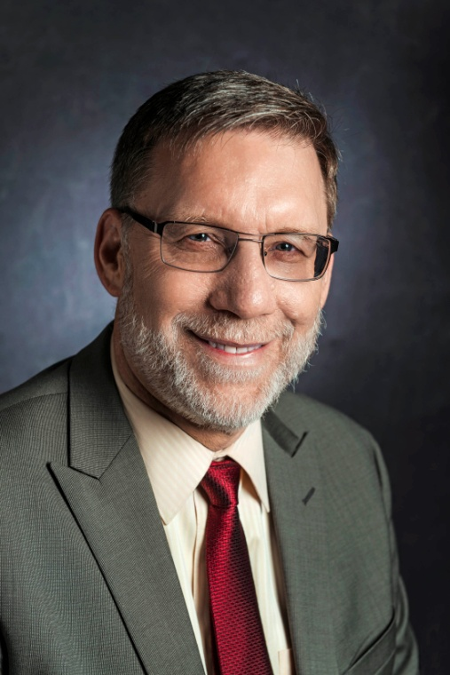

"'I Call You Friends': Toward a New Theology of Vocation"

Traditional Catholic understandings of vocation often focus on four states of life: 1) consecrated religious life, priesthood, Christian marriage, the single Life. This presentation will proposed a theology of vocation that focuses on the call to Christian friendship as the primary relational vocation of all the baptized. Within this framework consecrated religious life would be understood as a form of "evangelical friendship" and marriage as a form of "sacramental friendship."

Dr. Richard R. Gaillardetz is the Joseph Professor of Catholic Systematic Theology at Boston College and is currently the chair of the theology department. Prof. Gaillardetz received his Ph.D. in systematic theology from the University of Notre Dame. He has published over 140 articles and authored or edited 14 books. Most recently he published a newly revised and expanded edition of his popular book, By What Authority? Foundations for Understanding Authority in the Church (Liturgical Press, 2018). In 2000 he received the Sophia Award from the Washington Theological Union for theological excellence in service of ministry and in 2018 he received the Yves Congar Award for theological excellence from Barry University. Dr. Gaillardetz served as president of the Catholic Theological Society of America in 2013-14. He and his wife Diana are the parents of four adult sons.

Thursday Morning Keynote Speaker: Sr. Margo Ritchie, CSJ
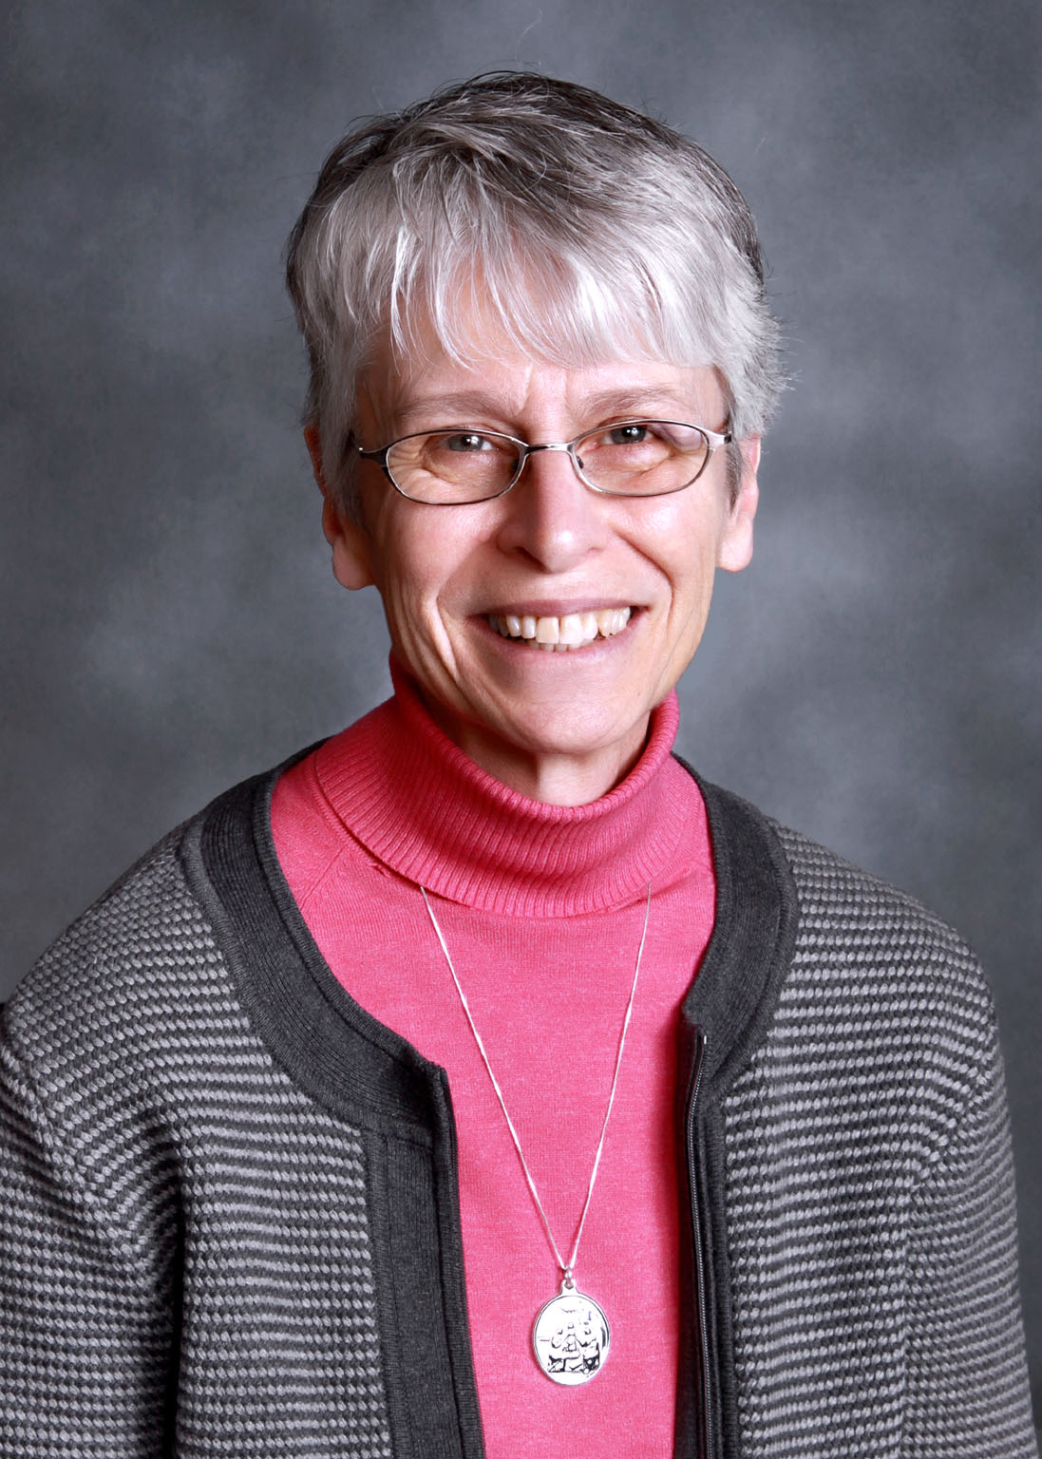

Where is This Place Called ‘Here’?
Borrowing a phrase from Irish poet Padraig O Tuama, Margo will begin to describe the landscape of this place called ‘here’ as a starting point for conversation among us. How we name this place called ‘here’ influences what we see…and what we don’t see. Through the lens of call she will explore with us the image of the “adjacent possible”.
Sr. Margo Ritchie, CSJ
Margo is a Sister of St. Joseph whose life has taken her from teaching high school to being a co-director of a home for women in transition, to the work of spiritual direction at a retreat house in London. Her service now is the very interesting work of leadership within her Congregation.
She cares about making the world a more hospitable place for everyone and learning ways to live more humanly together.

Friday Morning Keynote Speaker: Fr. Dan Horan, OFM, PhD
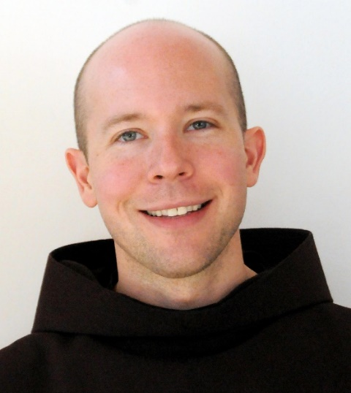

Discernment, Vocation, and Formation in the Thought of Pope Francis

In keeping with the vision of a universal call to holiness expressed in the documents of the Second Vatican Council, Pope Francis has frequently written and spoken about need to attend to discernment in the lives of all the baptized. Recognizing consecrated religious life and ministerial priesthood as subsets of a broader theology of vocation, this presentation explores what the pope’s contributions to the themes of discernment and vocation have to offer to renewed consideration of religious formation and vocation ministries.

Daniel P. Horan, OFM, is a Franciscan friar of Holy Name Province (NY), assistant professor of systematic theology and spirituality at Catholic Theological Union in Chicago, a columnist for the National Catholic Reporter, and the author of twelve books including the award-winning The Franciscan Heart of Thomas Merton: A New Look at the Spiritual Influence on his Life, Thought, and Writing(2014). His latest books are titled, Reading, Praying, Living Pope Francis’s Rejoice and Be Glad (2019) and All God’s Creatures: A Theology of Creation (2018). His next book, due out in Fall 2019 with Orbis Books, is titled: Catholicity and Emerging Personhood: A Contemporary Theological Anthropology. He is the author of numerous popular and scholarly articles and is a frequent lecturer and retreat director around the United States, Canada, Europe, Australia, and New Zealand. Fr. Dan currently serves on the Board of Trustees of St. Bonaventure University in New York and the Board of Regents of the Franciscan School of Theology in California. He is also co-host of The Francis Effect Podcast. He received his PhD in theology from Boston College, MDiv and MA from the Washington Theological Union (DC), and a BA from St. Bonaventure University. For information, visit www.DanHoran.com
Our Facilitator: Sr. Elizabeth Davis, RSM, PhD

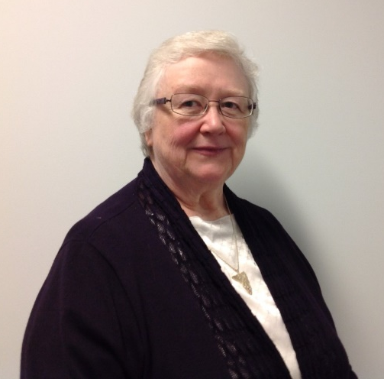

Elizabeth Davis is the Congregational Leader of the Sisters of Mercy of Newfoundland and Labrador. In that role, she has special leadership responsibilities for St. Patrick’s Mercy Home, The Gathering Place, and Mercy Centre for Ecology and Justice. She has been a high school teacher and a health care administrator. She has recently completed doctoral studies in Scripture at the University of Toronto. Among her awards are membership in the Order of Canada and the Order of Newfoundland and Labrador as well as honorary doctoral degrees from Memorial University of Newfoundland and the University of Manitoba.

Update from our U.S. Counterparts:
Sr. Deborah Borneman, SS.C.M., MDiv, MA is the Executive Director of Member Relations and Services at the National Religious Vocation Conference (NRVC). She will bring us up to date on the activities of vocation ministry in the USA.

Sr. Ellen Dauwer, SC, PhD is a Sister of Charity (Convent Station, NJ) and serves as Executive Director of the Religious Formation Conference, (RFC). She will be on hand to give us an update on formation activities in the United States.

5. Workshop Session Details
1.The Dawning Future of Religious Life: Germinating and Radiating-- Brenda Peddigrew, RSM, PhD
Although we see a significant diminishing of numbers in our Canadian ways of living religious life, and many of our familiar Congregations are coming to conscious completion, it is most important at this time to recognize and attend to the deep and abiding influences that our Congregations have had and still have. Instead of “ending” we are really in “germination”, and our good influence in the world continues to radiate wherever we are or have been. The soul of this workshop is the recognition and practice of seeing how the heart of religious life continues in different forms, and will continue long after traditional forms have transformed.
2. Do Monkeys Go to Heaven? The Beauty and Wisdom of Faith and Science-- Rev. John W. McCarthy, SJ, PhD
There persists a seemingly widespread notion that religious faith and empirical science must, by necessity, be in conflict. Yet as many contemporary scholars of the history of science tell us, the relationship is much more complex than that.
Properly understood, science and religion are not in conflict but act as fruitful partners in a healthy dialogue that seeks the truth of the fullness of human experience. Placing biological evolution in dialogue with the Christian theology of creation, we will examine the wisdom and beauty of science and faith. We will consider the vast, wondrous world of “both/and” rather than the limited, oppressive world of “either/or.” Both science and faith deal with data – albeit data of a different character and quality. Both scientific and theological/philosophical inquiry need to be taken seriously. It is in charitable and welcoming dialogue that any semblance of truth may be attained.
3. Formation that Nurtures Transformative Servant Leadership—Sr. Miriam K. Martin, PBVM, PhD
I have meaningful and challenging conversations both within my NL Province and the larger International Presentation Congregation about formation for emerging leaders within our groups. It is evident that leadership development for religious life and ministry is nurtured in initial formation. In these evolving times within religious life, mature human development and a commitment to a communal way of life play a signiﬁcant role in drawing persons into living and leading with depth, authenticity, and creativity. This is a movement towards transformative servant leadership.
4. Narratives of Expanding Relations—Morgan Gardner, PhD
Exploring our personal and culture narratives of expanding relations to our human and more-than-human world is at the heart of today’s spiritual life. How do we stand-in-relation to our global human and ecological world? How do we navigate this complex, sacred journey that is spirit-filled with dreams and possibilities and also fraught with challenges and ‘crises’ of faith? How are our identities, commitments and expressions of agency being transformed by living in greater relation to all of life? This workshop shares stories of individuals and groups reflecting on their spiritual journeys – their pilgrimages of expanding their embodiment of relational being and practice. In doing so, this workshop becomes an invitation to reflect on our own journeys of expanding relations.
5. Who are our Newest Members? A Look at Millennials and Gen Z--
Sr. Ellen Dauwer, SC, PhD
This presentation will begin with an overall look at the two most recent generations: Millennials and Gen Zeders. It will then focus on Catholics in these generations and conclude with a look at characteristics of members of these generations who are entering religious life. CARA and Pew research will form the foundation of the presentation.
6. Catechetical Formation of Candidates for Religious Life: Challenges and Opportunities--Tony Bidgood, C.Ss.R., MDiv
7. Together for Mission: Formation of Associates of Religious Institutes—Anne Walsh, DMin
In this presentation, we will explore charisms as gifts of the Holy Spirit to the Church. Together, we will explore the dimensions of charism, and ask how new vision and understanding might lead us to new possibilities for identifying, inviting, forming and calling associates to greater missionary involvement.
8. More Than a Google Search: Vocation/Formation Ministry with Youth in Light of Christus Vivit-- Susan O’Keefe-DiFederico, M.Div, S.T.B., B.Ed.
In this workshop we will explore The Post-Synodal Apostolic Exhortation Christus Vivit, and how it calls us to be people who radiate life and people who awaken the kerygma! This letter reminds us that we need each other; we need our elders to nourish our roots and we need the youth to spread their branches reaching to the sky as a song of hope (179). Christus Vivit offers us a framework to speak openly about serious issues within our church and opportunities for the future of youth ministry. We are invited to steer our mission with youth towards new shores; the streets, cyber communities and athletic, musical and social justice spaces where youth gather. Searching together to find meaning, purpose and joy as Christ is Alive!!

9. Due Diligence in Vocation Ministry—Sr. Deborah Borneman, SS.C.M., MDiv, MA
Vocation ministers have the right to gather the data they need for due diligence in candidate assessment yet safeguard the candidate's right to minimal intrusion. This workshop is designed to update participants on the trends, best practices, and challenges of contemporary vocation ministry. Using a case study approach, participants will delve deeper into candidate issues that delay or preclude admission. Topics include the demographics to consider when inviting discerners and the latest research on newer members.

Workshops Registration

Please choose only ONE workshop from each block and record your choice in the space provided on the Registration form.
Thursday, April 30
Workshop Block 1
2:00—3:15 p.m.
1. The Dawning Future of Religious Life: Germinating and Radiating
2. Do Monkeys Go to Heaven? The Beauty and Wisdom of Faith and Science
3. Formation that Nurtures Transformative Servant Leadership

Friday, May 1

Workshop Block 2
2:00—3:10 pm

4. Narratives of Expanding Relations
5. Who are our Newest Members? A Look at Millennials and Gen Z
6. Catechetical Formation of Candidates for Religious Life: Challenges and Opportunities

Saturday, May 2

Workshop Block 3
9:00—10:15 am

7. Together for Mission: Formation of Associates of Religious Institutes
8. Youth Ministry
9. Due Diligence in Vocation Ministry

This will be a wonderful conference and the Planning Committee and the Board are delighted to welcome you to this exciting gathering.

If you have any questions, feel free to contact: Sr Nancy Sullivan, Executive Director of NAVFD at navfdco@gmail.com
- NAVFD Conference 2020 Registration Form
April 29 - May 2, 2020
St. John’s, Newfoundland

Name: _________________________________________________________________
Title First Last
Address: _______________________________________________________________

City: __________________ Prov/State: ________ Postal Code/Zip Code: ___________

Country: ________________________________ Telephone #: (___)_______________

Email address: ___________________________________________________________

Congregation/Diocese/Organization Name (and initials if applicable): ________________
_______________________________________________________________________

Conference Fees in Cdn $:
NAVFD Member Before March 15- $450 After March 15- $475
Non-NAVFD Member Before March 15- $500 After March 15- $525

Please make your cheque, money order or bank draft for your registration payable to NAVFD and send with this registration form to:
NAVFD Conference 2020
St. Teresa's Parish
120 Mundy Pond Road
St. John's, NL A1E 1V1

Payment may also be made through PayPal: http://navfd.info/donate/

Optional Tour on Saturday Afternoon:

____ Yes, I wish to take the tour and have included $65.00 in my cheque.
____ No, I do not wish to take the tour.

Cancellation Policy: There is no penalty if registration is cancelled before April 5, 2020. Any cancellation after April 5, 2020 will not be refunded. Substitutions are acceptable at any time.

Special Meal Needs: ____________________________________________________

Workshop Choices: Please see the Workshop Session descriptions and choose one from each block and place the number in the space below:

Block 1: ______________ Block 2: ________________ Block 3: ________________

6. Conférence NAVFD 2020 - Formulaire d’inscription
29 avril – 2 mai, 2020
St. John’s, Newfoundland

Nom:__________________________________________________________________
Titre Prénom Nom
Adresse: _______________________________________________________________

Ville: ______________________ Province/État: ________ Code postal : ____________

Pays: ____________________ Numéro de téléphone: (_____)_____________________

Adresse courriel: _________________________________________________________

Nom de la congrégation/du diocèse/de l’organisation (et initiales, le cas échéant): _____
_______________________________________________________________________

Frais de la conférence en $ canadien :
Membre de NAVFD avant le 15 mars- $450 après le 15 mars- $475
Non-membre de NAVFD avant le 15 mars- $500 après le 15 mars- $525

Pour votre inscription, veuillez libeller votre chèque, mandat ou traite bancaire au nom de NAVFD et l’envoyer avec ce formulaire d’inscription à:

NAVFD Conference 2020
St. Teresa's Parish
120 Mundy Pond Road
St. John's, NL A1E 1V1
Vous pouvez également payer par PayPal (au Canada seulement): http://navfd.info/donate/

Visite facultative le samedi après-midi :
____ Oui, je souhaite faire le tour et avoir inclus 65,00 $ dans mon chèque.
____ Non, je ne souhaite pas faire le tour.

Politique d’annulation: Il n’y a pas de pénalité si l’inscription est annulée avant le 5 avril 2020. Les substitutions sont acceptables en tout temps.

Besoins alimentaires spéciaux : ___________________________________________

Choix d’ateliers: Veuillez lire les descriptions des sessions d’ateliers, en choisir une de chaque bloc, et placer le numéro qui correspond à votre choix dans l’espace ci-dessous :

Bloc 1: _______________ Bloc 2: ___________________ Bloc 3: __________________

OPTIONAL Historic St. John’s & Cape Spear Tour
Saturday, May 2, 2020
1-4 p.m.
Cost: $65.00 per person

Operated by hosts: McCarthy’s Party
Departs from the main door of the Sheraton Hotel,
and returns to the Sheraton at conclusion of tour.

Become acquainted with the city of St. John's and its surroundings, including Cape Spear, the most Easterly point in North America. This is the oldest colonized region in the new world and your local guide will regale you with its steeped history, legends & lore - all flavoured with their personal anecdotes and good humour from which Newfoundlanders are so famous. Enjoy the brilliant vistas from Cabot Tower and Signal Hill, one of the most recognizable skylines in Canada. Walk through a cliffside World War II gun battery, watch for whales and seabirds and visit the oldest standing lighthouse in North America. Other stops include Quidi Vidi Village, Jelly Bean Row, Government House, the Roman Catholic Basilica and an orientation of the shops and restaurants of the downtown core.
To reserve a place on the tour, please check the appropriate section in the conference registration form, and add $60.00 to your registration cheque.

