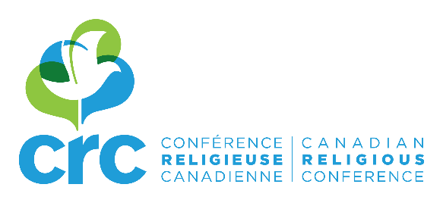

REGISTRATION FORM

The art of living and dying
Saturday, April 14, 2018 (8:30 a.m. – 3:15 p.m.)

Institut de pastorale des Dominicains
2715, chemin de la Côte-Sainte-Catherine
Montreal QC H3T 1B6

Cost: $40 (lunch included)

Name: _____________________________________________________________________
Community/Organisation: _____________________________________________________
Please, check your status:
☐ Congregational Leader
☐ Congregational Member
☐ Lay Associate
☐ Lay Person
E-mail: _____________________________________________________________________

Please use one registration form per participant and send them by e-mail to Nathalie Gauthier: ngauthier@crc-canada.org

PAYMENT WILL BE AT THE DOOR.

Means of payment:
- Cash
- Cheque (payable to “Canadian Religious Conference” or “CRC”)

If you register several persons, please join one cheque for all participants.

Information: info@crc-canada.org
Registration: Nathalie Gauthier, ngauthier@crc-canada.org

